WEEK 2:
Exploratory data analysis (EDA) and Visualization Framework

SUBMITTED BY:
Krishna Yadav

COURSE:
Bachelor of Computer Applications (BCA)

INTERNSHIP:
Data Science Internship

T00LS:
Pandas, NumPy, Matplotlib, Seaborn, Ploy , Jupyter Notebook

INTRODUCTION

INTRODUCTION TO EXPLORATORY DATA ANALYSIS
Exploratory Data Analysis (EDA) is an
important stage of the data science process used to understand, summarize, clean, and investigate a dataset before applying
statistical or machine learning techniques.
EDA helps a data analyst identify patterns, trends, relationships, unusual observations, missing values, duplicate records, and
potential errors in the data.
In a Student Performance Data Analysis project, EDA can be used to understand how factors such as study time, attendance, previous scores, parental education, and other variables may be associated with
students' academic performance.
EDA generally combines statistical techniques with data visualization. Numerical summaries provide quantitative information, while graphs and charts make patterns easier to understand.

IMPORTANCE OF EDA
- The major purposes of EDA are:
- To understand the structure of the dataset.
- To identify different types of variables.
- To detect missing and duplicate values.
- To identify unusual or extreme observations.
- To understand distributions of variables.
- To discover relationships between variables.
- To identify trends and patterns.
- To support better decision-making.
- To prepare reliable data for further analysis or machine learning.

EDA therefore acts as a bridge between raw data and meaningful insights.

OBJECTIVES OF EDA

OBJECTIVES OF THE EDA FRAMEWORK

The proposed EDA framework will follow a systematic process that can be adapted to different datasets.

MAIN OBJECTIVES
- Understand the dataset and its structure.
- Identify numerical and categorical variables.
- Examine data quality.
- Detect missing values and duplicates.
- Identify and investigate outliers.
- Analyze individual variables.
- Study relationships between variables.
- Discover patterns using visualizations.
- Generate useful statistical summaries.

PROPOSED EDA WORKFLOW

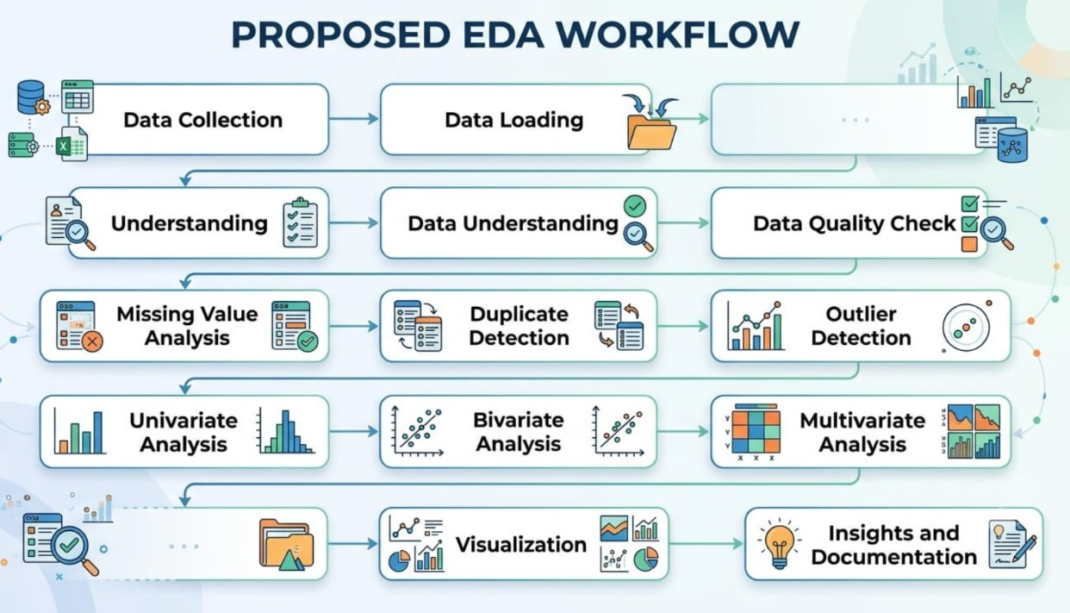

POTENTIAL DATA TYPES

UNDERSTANDING POTENTIAL DATA TYPES

Identifying data types is an essential first step because different types of variables require
different analytical and visualization techniques.
  - NUMERICAL DATA
Numerical data represents measurable quantities. Examples:
Age
Study hours
Attendance percentage Marks
Test scores
Numerical data can be further classified into:
Discrete Data: Values that are countable, such as number of subjects or number of assignments.
Continuous Data: Values that can take a range of values, such as study hours or average marks.
  - CATEGORICAL DATA

Categorical data represents groups or categories. Examples:
Gender School type Course Location
Parent education level
  - ORDINAL DATA
Ordinal data contains categories with a meaningful order.
Examples:
Low, Medium, High
Poor, Average, Good, Excellent Education levels
  - BOOLEAN DATA
Boolean data contains two possible values. Examples:
Yes / No True / False
Passed / Failed
  - DATE AND TIME DATA

Datetime variables contain dates or timestamps. Examples:
Examination date Admission date
Assignment submission date
Text data contains free-form textual information.

HANDLING MISSING DATA

5. MISSING DATA ANALYSIS AND TREATMENT
Missing values occur when information is unavailable for one or more observations.
Missing data can affect statistical analysis and visualization, so it should be identified and handled appropriately.

METHODS FOR IDENTIFYING MISSING DATA
The analysis should determine:
- Number of missing values in each column.
- Percentage of missing values.

- Variables with the highest amount of missing data.
- Whether missing values follow a particular pattern.

METHODS FOR HANDLING MISSING DATA
- Removing Records
Rows with a very small number of missing values may sometimes be removed.
- Mean Imputation
Missing numerical values can be replaced using the mean when appropriate.
- Median Imputation
The median can be used when numerical data contains outliers or is highly skewed.
- Mode Imputation
The most frequent category can be used for some categorical variables.

UNIVARIATE ANALYSIS
UNIVARIATE ANALYSIS
Univariate analysis examines one variable at a time.
Its purpose is to understand the distribution, central tendency, variability, and frequency of individual variables.

NUMERICAL VARIABLES
For numerical variables, the following can be examined:
- Mean
- Median
- Minimum
- Maximum
- Standard deviation
- Quartiles
CATEGORICAL VARIABLES
:
Frequency For categorical variables, the analysis can examine
- Percentage distribution
- Most common category
- Number of unique categories

RECOMMENDED VISUALIZATIONS
- Histogram
- Box plot
- Bar chart
- Pie chart, when appropriate
- Example
- For a student performance dataset, a histogram can show the distribution of student marks, while a box plot can show the spread and potential outliers.

EXAMPLE
For a student performance dataset, a histogram can show the distribution of
student marks, while a box plot can show the spread and potential outliers.

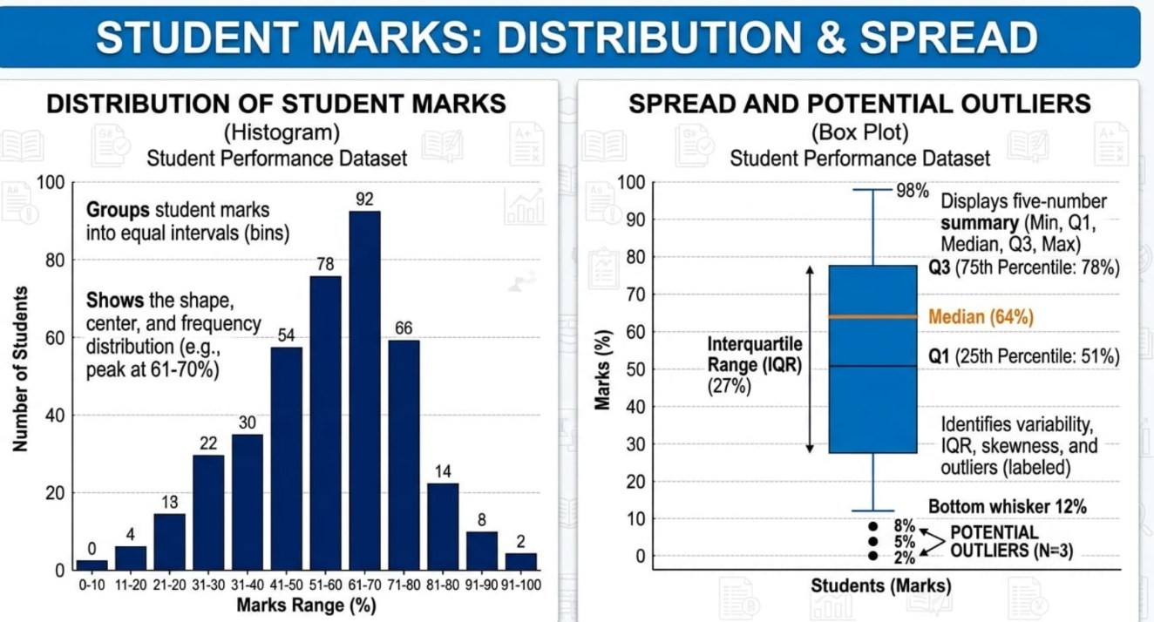

Bivariate Analysis
Bivariate analysis studies the relationship between two variables.
It helps determine whether changes in one variable are associated with changes in another variable.

NUMERICAL VS NUMERICAL
Example:
Study Hours vs Final Marks
- Recommended visualization:
- Scatter plot
- Regression plot

GENDER VS FINAL MARKS
Recommended visualization:
- Box plot
- Violin plot
- Bar chart

CATEGORICAL VS CATEGORICAL
Example:

School Type vs Pass/Fail Status
Recommended visualization:

- Grouped bar chart
- Stacked bar chart
- Contingency table

KEY QUESTIONS
Bivariate analysis
- Does study time appear related to marks?
- Do different groups have different average scores?
- Is attendance associated with academic performance ?

Multivariate Analysis
Multivariate analysis examines three or more variables simultaneously.
It is useful for discovering complex relationships that may not be visible when variables are studied individually.

EXAMPLES

A student's final performance could be analyzed using:
- Study hours
- Attendance
- Previous marks

- Assignment scores
- Test scores

RECOMMENDED TECHNIQUES
- Correlation matrix
- Heatmap
- Pair plot
- Multi-variable scatter plots
- Grouped visualizations

CORRELATION ANALYSIS
Correlation measures the strength and direction of association between numerical variables.

A correlation matrix can be visualized using a heatmap.

Interpretation generally includes:
- Positive relationship
- Negative relationship
- Weak relationship
- Strong relationship
Correlation should not automatically be interpreted as causation.

VISUALIZATION STRATEGIES

PROPOSED VISUALIZATION FRAMEWORK

Data visualization is an essential component of EDA because visual representations make complex information easier to understand.

The visualization strategy will be selected according to the variable types and analytical objective.

10.1 HISTOGRAM
Used to understand the distribution of numerical variables.
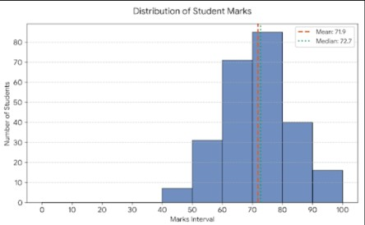

0.2 BAR CHART
Used to compare values across categories.
Example: Average marks by gender or school type.

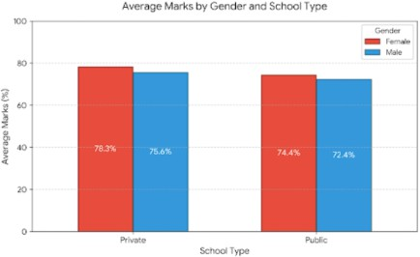

10.3 BOX PLOT
Used to examine:
Median Quartiles Data spread
Potential outliers
Example: Marks distribution across different groups.

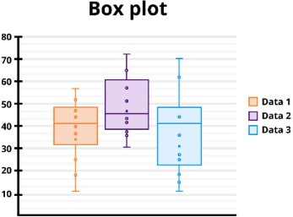

10.4 SCATTER PLOT
Used to study relationships between two numerical variables.
Example: Study hours versus final marks.
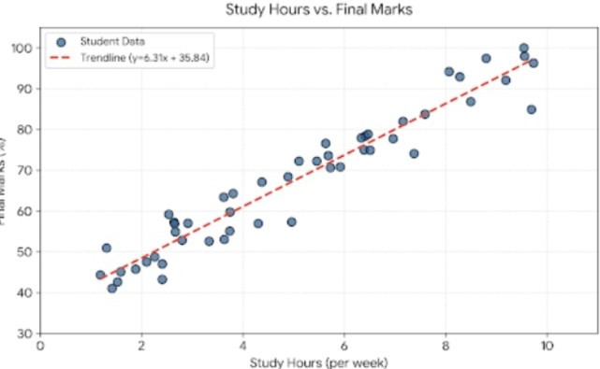

Python Libraries and Tools
PANDAS
Pandas is used for:
- Data loading
- Data cleaning
- Data transformation
- Missing-value analysis
- Statistical summaries
- Data manipulation

NUMPY
NumPy provides numerical computing capabilities and supports:
- Mathematical operations
- Arrays
- Statistical calculations
- Numerical transformations

MATPLOTLIB
Matplotlib is a general-purpose visualization library.
- It can be used to create:
- Line charts

- Bar charts
- Histograms
- Scatter plots

SEABORN
Seaborn provides high-level statistical visualizations.
- It is particularly useful for:
- Heatmaps
- Pair plots
- Distribution plots
- Box plots
- Relationship analysis

PLOTLY
Plotly can create interactive visualizations.
It can be used when users need to explore charts dynamically.

Reporting and Documentation Plan
EDA findings should be documented clearly so
that other people can understand the analysis and reproduce the process.
PROPOSED FINAL REPORT STRUCTURE

- Executive Summary
A brief overview of the project and major findings.

- Dataset Overview
Description of:
  - Number of records
  - Variables
  - Data types
  - Data sources

- Data Quality
Discussion of:
  - Missing values
  - Duplicates
  - Outliers
  - Data inconsistencies

- EDA Findings
Important observations from:
  - Univariate analysis
  - Bivariate analysis
  - Multivariate analysis

- Visualization Results
Charts should be presented with:
  - Titles
  - Axis labels
  - Short explanations

- Key Insights
The most important patterns and relationships should be summarized.

- Limitations
Any limitations of the dataset or analysis should be clearly stated.

- Conclusion
A concise summary of the overall findings and possible next steps.

EXPECTED FINDINGS
EXPECTED OUTCOMES OF EDA
Since an actual dataset is not provided for this assignment, the framework focuses on
potential findings rather than claiming specific results.
The EDA process may help identify:
- Distribution of student performance.
- Differences in performance between groups.
- Relationship between study time and marks.
- Relationship between attendance and academic performance.
- Variables with strong or weak associations.
- Unusual student records.
- Missing or inconsistent information.
- Important factors that may require further investigation.
These findings can later be used to guide statistical analysis or machine-learning model development.

POTENTIAL CHALLENGES AND SOLUTIONS

CHALLENGES AND PROPOSED SOLUTIONS

Challenge 1: Missing Values
Solution: Analyze the amount and pattern of missing data and select an appropriate treatment method.

Challenge 2: Outliers
Solution: Investigate whether outliers represent errors or genuine observations before deciding how to treat them.

Challenge 3: Inconsistent Categories
Solution: Standardize category names and formats.

Challenge 4: Large Dataset

Solution: Use efficient Pandas operations and appropriate sampling or aggregation techniques when necessary.

Challenge 5: Misleading Visualizations
Solution: Select charts according to the data type and analytical objective.

Challenge 6: Correlation Misinterpretation
Solution: Clearly distinguish association from causation.

Challenge 7: Too Many Charts
Solution: Include only visualizations that communicate meaningful information.

QUALITY CHECK AND REPRODUCIBILITY

QUALITY ASSURANCE
Before finalizing the EDA, the following checks should be performed:

- Verify column names and data types.
- Confirm missing-value treatment.
- Check duplicate records.
- Validate outlier handling.
- Verify calculations.
- Check visualization labels.
- Ensure charts are readable.
- Confirm that conclusions are supported by evidence.
- Maintain consistent formatting.
- Document important assumptions.

REPRODUCIBILITY
The analysis should be organized so that another analyst can understand and reproduce the process.

The documentation should include: Tools used.
- Libraries used.
- Data preparation steps.
- Analytical methods.

- Visualization methods.
- Important assumptions.
- Key findings.

COMPLETE EDA FRAMEWORK

END-TO-END EDA FRAMEWORK
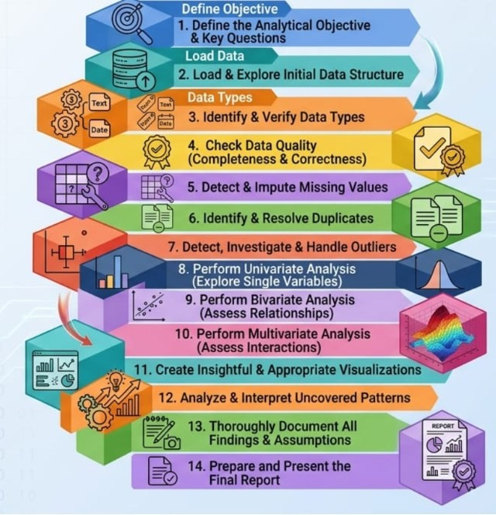

This process provides a systematic and adaptable approach that can be applied to student performance datasets as well as many other types of datasets.

Conclusion
Exploratory Data Analysis is one of the most important stages of a data science project. It provides an understanding of the structure, quality, distribution, and relationships
present in a dataset before advanced analysis or machine-learning techniques are applied.
The proposed framework covers the complete EDA process, including data-type
identification, data-quality assessment, missing-value handling, duplicate detection, outlier analysis, univariate analysis, bivariate analysis, and
multivariate analysis.
Visualization techniques such as histograms, bar charts, box plots, scatter plots, line

charts, heatmaps, pair plots, and violin plots can help communicate patterns
effectively.
Python libraries such as Pandas, NumPy, Matplotlib, Seaborn, and Plotly provide the necessary tools for performing these tasks.
Although no actual dataset is provided for this task, the framework is designed to be adaptable to different datasets. Once a real
dataset becomes available, the proposed process can be implemented to generate meaningful insights and prepare the data for further statistical analysis or machine-learning applications.
Overall, this Week 2 framework establishes a strong foundation for practical data analysis and visualization.

